


Computer Networks 41(2003) 475–487

www.elsevier.com/locate/comnet

A new class of QoS routing strategies based on network
graph reduction^{q}

C. Casettiª, R. Lo Cignoª, M. Melliaª, M. Munafo^{a,*}, Z. Zso^{b}
a Dipartimento di Elettronica, Politecnico di Torino, Corso Duca degli Abruzzi 24, I-10129 Torino, Italy
b Department of Telecommunications, Budapest Universityof Technologyand Economics, Magyar tudosok k€rutja 2,
1117 Budapest, Hungary
Received 15 October 2002; received in revised form 16 October 2002; accepted 24 October 2002
Responsible Editor: I.F. Akyildiz

Abstract

This paper discusses a new approach to QoS routing, introducing the notion of algorithm resilience (i.e., its ca-
pability to adapt to network and load modiﬁcations) as performance index of the algorithm itself.
The new approach can be summarized as Network Graph Reduction, i.e., a modiﬁcation of the graph describing the
network before the routing path is computed, in order to exclude from the path selection over-congested portions of the
network. This solution leads to a class of two-step routing algorithms, where both steps are simple, hence allowing
eﬃcient implementation.
Simulation experiments, run on randomly-generated topologies and traﬃc patterns, show that these routing algo-
rithms perform consistently better than both the standard Minimum Hop algorithm and those QoS-based algorithms
based on the same metrics but not using the notion of Network Graph Reduction.
2002 Elsevier Science B.V. All rights reserved.

Keywords: QoS routing; Routing algorithms; MPLS

1. Introduction

Dynamic, QoS-based routing received consid-
erable attention in recent years [1–7], especially
considering the diﬃculty in predicting Internet

q This work was supported in part by the Italian Ministry for
University and Scientiﬁc Research through the PLANET-IP
Project. A preliminary version of this paper was presented at
IEEE Infocom 2002 in New York.
* Corresponding author.
E-mail address: munafo@polito.it (M. Munafo

traﬃc patterns and the consequent impossibility to
properly plan and dimension the network.
The core of any QoS-based routing algorithm is
a network-status-dependent cost function that is
used to ﬁnd the optimal (or at least a suitable)
route across the network by solving an optimiza-
tion problem. In particular, given the best-eﬀort
nature of the current Internet where elastic data
ﬂows are in the majority, the most commonly used
metric aims at the maximization of either network
utilization or user throughput. Several proposals
introduced cost functions, algorithms and proto-
cols that give them advantages over traditional,

1389-1286/02/$ - see front matter 2002 Elsevier Science B.V. All rights reserved.
PII: S 13 8 9 - 12 8 6 ( 0 2 ) 0 0 4 14 - 0

476

C. Casetti et al. / Computer Networks 41 (2003) 475–487

topology-based algorithms such as the Minimum
Hop (MH)¹presently used in TCP/IP networks
[8,9]. For example in [1], the authors introduce the
bottleneck bandwidth as a metric and then deﬁne
the maximization of user throughput as optimi-
zation target. Similarly, in [2,3] the authors study
how to improve the throughput of high-bandwidth
traﬃc, such as large ﬁle transfers, in a network
where resources are fairly shared among connec-
tions. Their ﬁndings, obtained by simulation, show
that, at high loads, a MH routing algorithm
maximizes network and user performance; for
low-congested networks, instead, they propose an
algorithm, named Minimum Distance (MD)
routing, which oﬀers better performance. However
they are unable to provide an algorithm that
merges the two behaviors. Researchers focused
their attention upon other aspects of QoS routing,
namely protocol overhead [5,7], implementation
issues [4,6], impact of update policies [5].
A major drawback, however, aﬀects all QoS-
based routing algorithms. The cost function at the
core of the algorithms tries to ﬁnd portions of the
network where resources are under-utilized and
exploits them to the beneﬁt of connections that
would otherwise cross a congested portion of the
network. In doing so, as shown in [11] for the case
of simple alternate routing, the algorithm ends up
consuming more resources than MH routing does,
hence, in case of heavy congestion, QoS-based
routing wastes resources and performs poorly
compared with MH. A formal proof of this ob-
servation can be found in [10]. The extension of
this property to TCP/IP networks is not straight-
forward, since ﬂows often exhibit a greedy, elastic
behavior, using up the available bandwidth. MH
routing has been already conjectured to be as-
ymptotically optimal as the load q oﬀered to the
network tends to inﬁnity, and many simulation
results conﬁrm this intuition [2,3,13,16]. We stress
at this point that the poor performance of QoS-
based routing at high loads is not due to the sub-
optimality of the used algorithms, but is rooted in
the locality of the routing decision. Whenever a

1 In this paper we refer to the MH algorithm as a special case
of the Shortest Path, in which all links have unitary costs.

call is routed, the given cost function is minimized/
maximized for the current state of the network,
necessarily disregarding the future network evo-
lution. Under heavy load, the overall network
beneﬁt does not coincide with the cost function of
a single call, hence the minimization of the one
does not lead to the maximization of the other.
In the light of the above discussion, the draw-
back of QoS routing in the Internet is clear:
whatever is gained at low or medium network
loads, it is paid for at high network loads. What is
needed to solve this problem is a resilient algo-
rithm that allows the migration of a QoS-based
routing algorithm to MH routing as q grows large.
The problem is that q is typically not known to the
routing algorithm, not even in the case of cen-
tralized routing algorithms.
The contribution of this paper lies in the iden-
tiﬁcation and deﬁnition of a class of routing algo-
rithms, named Network Graph Reduction (NGR),
whose performance encompasses that of QoS-
based routing algorithms at light and medium
loads, and the optimality of MH routing at high
loads. The goal is obtained by reducing the graph
that describes the network topology, and applying
a suitable metric to the reduced graph. Results are
reported showing both the elementary properties of
the algorithm, and its behavior in randomly gen-
erated topologies, both with uniform and non-
uniform, time-varying traﬃc.
The rest of the paper is organized as follows.
Section 2 provides a general description of the
NGR algorithm, along with implementation is-
sues. Section 3 presents the network and traﬃc
models used in the simulation presented in Section
4, in which the performance of the NGR algorithm
is compared to the one of classic QoS routing al-
gorithms, both in simple network scenarios, and in
more complex ones. Finally, conclusions and fu-
ture work are discussed in Section 5.

2. NGR routing algorithms

Routing can be formalized as the problem of
ﬁnding a suitable set of edges connecting two
nodes in a directed graph. QoS routing relies on
the deﬁnition of a suitable edge metric w, which

C. Casetti et al. / Computer Networks 41 (2003) 475–487

477

depends on the networks status, and of a cost
function cрЮ, which should be minimized/maxi-
mized, yielding the optimal route selection under
speciﬁc network conditions. As discussed in the
Introduction, however, all metrics and cost func-
tions that try to maximize network utilization or/
and user throughput suﬀer from the same draw-
back: as the network load increases (q ! 1) their
performance drops below that of a simple MH
algorithm. Finding metrics that let the path selec-
tion process converge to MH routing as q in-
creases seems to be a hard problem. As shown in
[16] the elastic nature of the Internet traﬃc just
worsens the problem. The diﬃculty of ﬁnding a
suitable metric lies in the fact that the goal of such
a metric should change with the network load,
making the problem not easily tackled by a stan-
dard minimization approach.
Indeed, we can look at the routing problem
from a slightly modiﬁed perspective. Instead of
trying to ﬁnd adaptive metrics, the same metric
that works well for light loads can be applied at
high loads to a reduced graph that only contains
uncongested links, i.e., links whose load is under a
given threshold. Since the reduced graph may not
be connected, i.e., no path may exist from a source
to a destination, the minimum-hop path should
always be included as possible solution of the
routing problem. Thus, as the oﬀered load q
grows, all links become congested and the algo-
rithm necessarily chooses the minimum-hop path.
While the direct measure (or evaluation) of q is a
complex task, the identiﬁcation of single congested
links is extremely easy, so that, overall, the meth-
odology is simple and its implementation straight-
forward.
This key idea leads to the deﬁnition of the NGR
strategy which can be applied to any existing QoS
routing algorithms.

2.1. Formal description

For the purpose of providing a formal de-
scription of the class of NGR algorithms in their
most general form, we use a standard graph theory
formalism. Thus, we refer to a generic network as
a directed graph G ј рV; EЮ, where V is the set of
vertices (nodes, in our case), and E is the set of

edges (links).²A path pрv_{s}; v_{d}Ю of length
n ј jjpрv_{s}; v_{d}Юjj is deﬁned as a sequence of n distinct
edges e_{i}joining v_{s}and v_{d}, where v_{s}; v_{d}2 V, e_{i}2 E,
pрv_{s}; v_{d}Ю ј fe₁; e₂; . . . ; e_{n}g.
A set P_{G}is deﬁned as the set of all paths ex-
isting between any two distinct vertices of G, i.e.,
P_{G}ј fpрv_{s}; v_{d}Юjv_{s}; v_{d}2 V; v_{s}6ј v_{d}g. Each link is
assigned a weight w using any metric that com-
bines topological, physical or traﬃc-related char-
acteristics of that link. To each path p a cost cрpЮ is
assigned using a combination of the weights of its
links. Following this, an order relation in the set
P_{G}is established among paths, and we will refer to
a path p_{i}as ‘‘lighter than’’ p_{j}if p_{i}p_{j}holds.
The NGR algorithm operates two subsequent
alterations upon the path set P_{G}, and applies se-
lection criteria on the resulting subset:

• Step 1: the ﬁrst alteration transforms the di-
rected graph G into G⁰ј рV; E⁰Ю, E⁰E, select-
ing only those links whose weight satisﬁes a
Cut-oﬀ criterion C (e.g., if w represented the link
capacity, ‘‘slower’’ links could be discarded
from path selection if w < w_{M}, where w_{M}is the
smallest acceptable capacity); as a result, the
path set PG is reduced to P_{G}0 after removing
those paths containing cut-oﬀ links;
• Step 2: let P_{mh}be the set including one mini-
mum-hop path from each source to each desti-
nation. In case more than one minimum-hop
path exist from the same source to the same des-
tination, one at random is selected.³The second
alteration transforms the path set P_{G}0 into
P⁰G⁰ј P_{G}0 [ Pmh; the new subset is built from
(i) the paths belonging to P_{G}0 and (ii) the mini-
mum-hop paths between any two nodes in V,
even if their links were discarded in the ﬁrst step.

Finally, the decision on how to route packets
between a source and a destination is made by ap-
plying the order relation to the path subset of P⁰G⁰
joining source and destination, and picking the path

2 In this paper we interchangeably use the terms ФedgesХ and
ФlinksХ and the terms ФverticesХ and ФnodesХ.
3 It is possible to optimize the Pmh set, for example using
load-balancing criteria.

478

C. Casetti et al. / Computer Networks 41 (2003) 475–487

that turns out to be the lightest according to the cost
metric deﬁned by the QoS routing algorithm.

2.2. NGR-MD and NGR-WS algorithms

In a broad sense the NGR methodology can be

where C_{l}is the link capacity and n_{l}is an esti-
mate of the number of active ﬂows currently
routed over link l.
The cost cрp_{i}Ю of path p_{i}is then deﬁned as fol-
lows:
X

coupled with any metric and cost function. In or-
der to exemplify this property, we considered the
cрp_{i}Ю ј

l2pi
w_{l};
р5Ю

application of this methodology to two algorithms
already proposed in the literature, which were
shown to oﬀer good performance [1,2]:
Widest-shortest (WS): for each source–destina-
tion pair, the algorithm determines all the paths
with the minimum-hop count; if more than one
such path exist, it breaks the tie by choosing the
and the ordering relation is such that p_{i}p_{j}if
cрp_{i}Ю < cрp_{j}Ю.
To implement the NGR algorithms, we deﬁne
the following:

Cut-oﬀ criterion C : a link is discarded if its utili-
zation is found to be above a given threshold W_{t}, i.e.,

one with the largest available bandwidth [1];
Minimum distance (MD): for each source–des-
b_{l}=c_{l}> W_{t}:
р6Ю

tination pair, the path is chosen which mini-
mizes the sum on each link of the inverse of
the equal bandwidth share [2].
To help the reader, we report a simple de-
scription of the above algorithms, using the nota-
tion introduced in this paper.

• WS path weight computation: a weight w_{l}associ-
ated to a generic link l is computed as
Combining NGR and C with either the MD or
WS QoS algorithms we obtain the NGR-MD and
NGR-WS algorithms.
In the rest of the paper, we assume W_{t}ј 1, i.e.,
if a link shows a 100% utilization, it is discarded by
the Cut-oﬀ criterion.

2.3. Implementation issues

After deﬁning the algorithms, we are interested

w_{l}ј b_{l};
р1Ю
in the viability of a consistent hop-by-hop imple-
mentation, in which routing decisions taken at an

where b_{l}is an estimate of the currently avail-
able bandwidth on link l;
The set of paths among which the path P_{G}is
chosen is restricted to the minimum-hop paths, i.e.,
P_{G}ј ffp_{i}рv_{s}; v_{d}Юj jjp_{i}рv_{s}; v_{d}Юjj 6 jjp_{j}рv_{s}; v_{d}Юjj 8jg
upstream node are not liable to be superseded by
downstream nodes ﬁnding a locally-optimal al-
ternative to the path chosen earlier by upstream
nodes. As formally proved in [12], the WS algo-
rithm does not belong to the class of algorithms
that allow a consistent hop-by-hop implementa-

8v_{s}; v_{d}g:
р2Ю
tion, while the MD algorithm can be implemented
in a hop-by-hop fashion while preserving consis-

Then, the cost cрp_{i}Ю of path p_{i}is deﬁned as follows:
tency. If we combine the NGR methodology

cрp_{i}Ю ј min fw_{l}g;
l2p_{i}
р3Ю
described above with those algorithms, is the hop-
by-hop implementation property preserved? Un-

and the ordering relation is such that p_{i}p_{j}if
cрp_{i}Ю > cрp_{j}Ю (i.e., p_{i}is lighter than p_{j}if its avail-
able bandwidth is larger than p_{j}Хs).
• MD path weight computation: a weight w_{l}asso-
ciated to a generic link l is computed as
n_{l}ю 1
fortunately, the answer is negative. The proof in
case of the NGR-MD metric is by counter-exam-
ple, while NGR-WS cannot be considered since
the WS criterion itself is not implementable hop-
by-hop. Consider the simple directed graph in Fig.
1, consisting of ﬁve links, a, b, c, d , z, each labeled
with its own weight, i.e., w_{a}ј 10, w_{b}ј 5, w_{c}ј 2,

w_{l}ј
C_{l}
;
р4Ю
w_{d}ј 2 and w_{z}ј 2. Let us consider the problem of

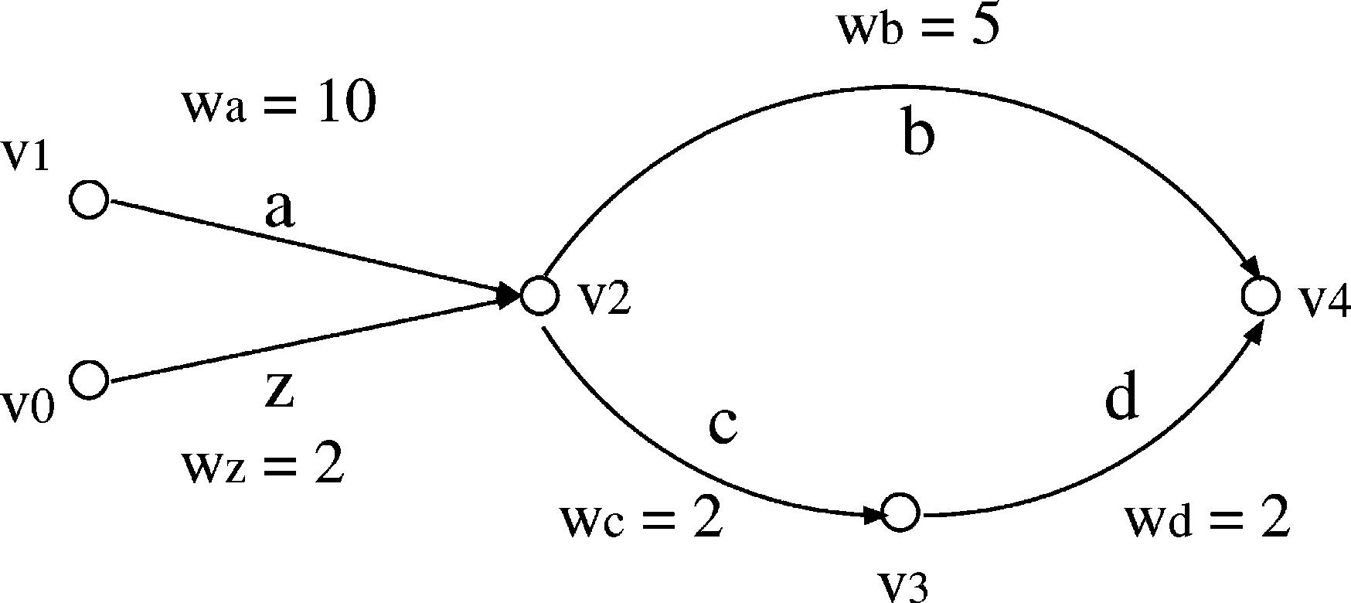

C. Casetti et al. / Computer Networks 41 (2003) 475–487

479

Fig. 1. Simple topology where the hop-by-hop implementation
of the NGR algorithm fails.

routing a packet from v₁to v₄according to the
NGR-MD criterion, locally implemented at each
node. For the sake of simplicity, we consider v₄as
the only destination, such that only paths ending
in v₄are listed in P_{G}.
Let us suppose that, of all links, only link a,
joining v₁and v₂, does not make the cut at Step 1,
being overloaded. As a consequence, the P_{G}0 path
set is рfbg; fz; bg; fz; c; d g; fc; d g; fdgЮ. Step 2,
however, reintroduces path fa; bg because it is the
minimum-hop path from v₁to v₄. Therefore, we
have P⁰G⁰ј P_{G}0 [ fa; bg. Since only one path
joining v₁and v₄is available, such path is the
natural choice to go from v₁to v₄.
However, from v₂Хs standpoint, the ordering is
such that path fc; dg is lighter than path fbg. It
follows that a packet reaching node v₂will travel
over links c and d, and not over link b, as was
originally meant by v₁.
This could happen every time a node along the
path follows the congested links, so that, from that
node on, the destination can be reached on the
path set P_{G}0 and not necessarily on the minimum-
hop path only, i.e., pрv₁; v₄Ю is congested, while
pрv₂; v₄Ю is not.
If we resorted to a hop-by-hop implementation
of the NGR algorithm, one possible disadvantage
is intuitively illustrated by considering paths (and
connections) from v₀to v₄, necessarily crossing
link z. Let us suppose that link z is lightly loaded,
and, therefore, that the choice of paths operated
by v₀is consistent with forwarding operations by
v₂, i.e., connections are routed over the fz; c; dg
path. At the same time, connections from v₁to v₄
are also forwarded by v₂over fc; dg, for the rea-
sons outlined above, thus overloading that path,

and possibly leading to routing oscillations and
performance degradation.
In the following, we will refer to a consistent
version of the NGR algorithms if routing decisions
taken at upstream nodes are not overruled by
downstream nodes, while we will refer to a hop-by-
hop version of NGR (NGR HbH) if every node
implements its own locally-optimal version of the
algorithm.
As pointed out above, for consistent routing to
be preserved, the forwarding procedures of the
NGR algorithm must be integrated so as to signal
the routing decision taken at upstream nodes. This
solution can be implemented using the route-pin-
ning property of the MPLS technology [14], or a
slight modiﬁcation of the IP forwarding proce-
dure.

2.3.1. MPLS implementation
If MPLS is used, each node can open a Label
Switched Path (LSP) on the minimum-hop path
toward each destination. Then, for each packet,
the edge router selects whether to route it using the
MPLS LSP, or using the classic hop-by-hop IP
routing over the best path selected using the QoS
routing algorithm. Potentially, a total number of
N рN 1Ю LSPs can be set up, where N is the
number of routers in the domain.
Another possibility is to always have an LSP
from each source to each destination, that can
either be routed through the QoS path, or through
the minimum-hop path in case no available QoS
path exists. This simpliﬁes the forwarding proce-
dure at each node, but requires a larger amount of
MPLS signalling, because the QoS paths are more
frequently updated than the minimum-hop paths.

2.3.2. Classic IP implementation
If, on the other hand, standard IP forwarding is
used, it is possible to have the edge router tag
packets (e.g., by setting a bit in the TOS ﬁeld of an
IPv4 packet header) when they are supposed to
travel along a minimum-hop path. This solution
prevents downstream nodes from choosing locally-
optimal paths.
By adding the above mentioned tag, the algo-
rithm is implementable using OSPF or IS–IS. Each
node has to compute and maintain two routing

480

C. Casetti et al. / Computer Networks 41 (2003) 475–487

tables, the ﬁrst for the minimum-hop paths, the
second for the QoS-based routing information. In
more detail:

• routers advertise QoS metrics for their outgoing
links according to the selected algorithm, e.g., as
computed by (3) or by (4);
• upon advertising them, routers mark links that
fail the cut-oﬀ criterion;
• when compiling their routing table, routers run
the minimum-hop algorithm with the usual 30-
min periodicity, using unitary metrics for each
link in the complete network graph; in this
way, the minimum-hop paths towards any desti-
nation are identiﬁed;
• with smaller periodicity, they run the QoS algo-
rithm, thus identifying the lightest path toward
any destination;
• for each destination, a router stores next-hop
entries associated to minimum-hop and to light-
est paths.

Upon reception of a packet, a router should
inspect its destination address and TOS ﬁeld; if a
match is found, the router will forward the packet
toward the next hop on the lightest path, unless
the packet is tagged, in which case the next hop in
the minimum-hop path is chosen.
As a ﬁnal remark, it should be noted that the
asymptotic computational complexity of the NGR
algorithms is the same as the complexity of the
QoS algorithms without graph reduction.

3. Evaluating routing algorithms

The performance evaluation of routing algo-
rithms is typically based on simulations. In this
paper, we adopt a traﬃc model and performance
evaluation tool, recently introduced in [15,16], that
matches the characteristics and the dynamics of
the Internet better than traditional connection-
based simulation tools. Additional information
about the tool itself, based on the ANCLES sim-
ulator, can be found in [15–17].
TCP/IP networks do not provide for connection
admission control, hence there is no limitation on
the number of concurrent connections on a given

path. The dominant Internet applications (namely,
all data-based applications over TCP) are elastic,
adapting the transmission speed to the available
resources. A connection is opened with a given
amount of data to transfer and it is closed either
when the transfer is complete, or when the user
tires of waiting and drops the session or when it is
reset. In other words, connection durations are not
known in advance, but are determined by data ﬁle
sizes and network conditions.
The evaluation tool we use takes the elastic
model into account. Speciﬁcally:

• ﬂows are characterized by a given amount of
data to transfer;
• the amount of resources the ﬂow can exploit at
any given time is the minimum between a target
bit rate for the ﬂow, e.g., the access line speed,
and what the ﬂow would be assigned under per-
fect max–min fair resource sharing;
• the ﬂow holding time depends on the resources
it receives throughout its ‘‘life,’’ which deter-
mine the amount of data already transmitted
at any given time;
• if the resources usable by a ﬂow fall below a gi-
ven threshold, the connection may be shut down
prematurely, mimicking the behavior of impa-
tient users.

The performance metrics we take into account
are:

• the fraction of connections are shut down due to
lack of resources;
• the average throughput of connections that
complete the data transfer;
• the overall throughput of the network.

Further details about the traﬃc model and the
evaluation methodology, as well as evidence of the
diﬀerence between this approach and more tradi-
tional ones can be found in [15,16].

4. Algorithm performance and resilience

The algorithm described in Section 2 necessarily
behaves as a MD or WS algorithm for uncon-

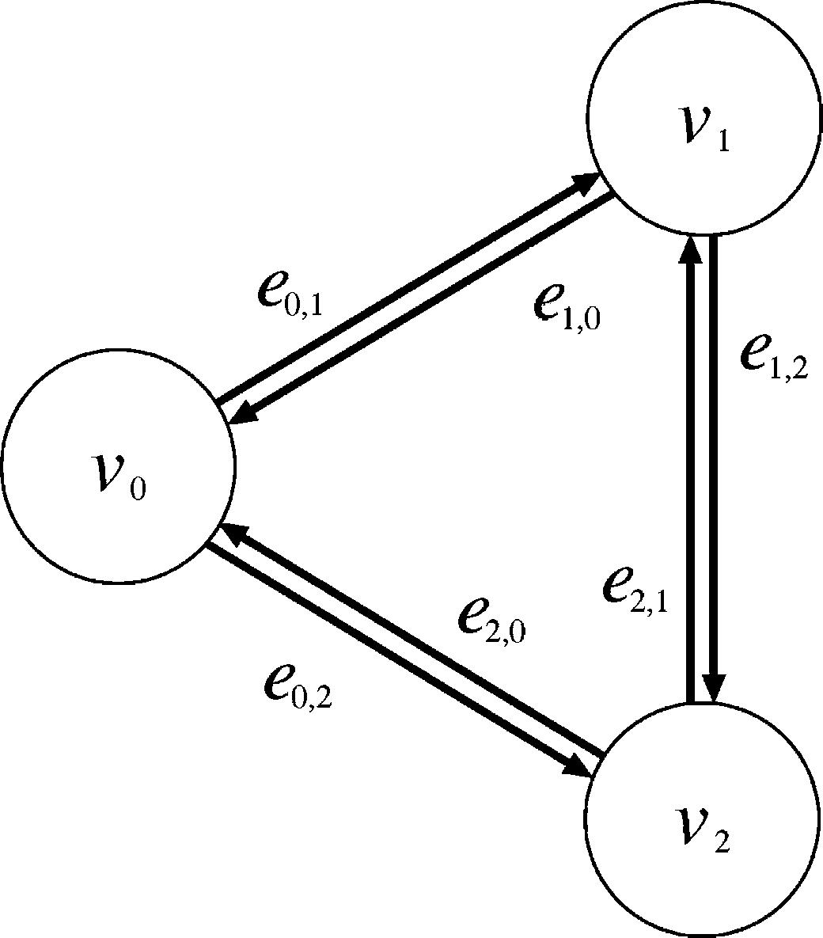
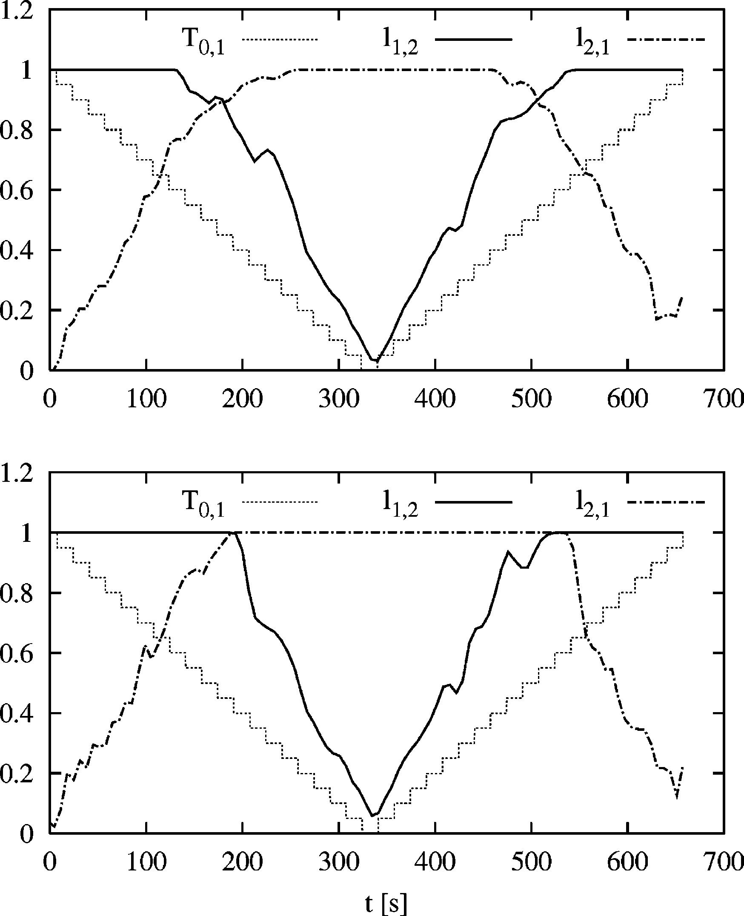

C. Casetti et al. / Computer Networks 41 (2003) 475–487

481

gested networks and as a MH algorithm as the
oﬀered load increases causing congestion; how-
ever, the behavior at intermediate loads can only
be investigated by simulation. For the sake of
comparison, result reports include the classic MD,
WS algorithms and the MH algorithms.
We separately consider two cases, analyzed in
the following two Sections. The ﬁrst one presents
elementary results on a trivial topology, which can
aid the understanding of the algorithms and verify
that the algorithms behave as expected. The sec-
ond one analyzes results in complex, randomly-
generated topologies and diﬀerent traﬃc patterns,
ensuring that the properties of the algorithm are
not bound by the choice of the topology or of the
traﬃc pattern.

4.1. Elementarybehavior

We consider the transient behavior on a trivial
tri-node topology as described in Fig. 2. Node v₀
generates all the traﬃc which is directed to nodes
v₁and v₂. All links e_{i};j are unidirectional with ca-
pacity 1. v₀starts sending all connection requests
to v₁, then progressively (and linearly) decreases
the amount of traﬃc directed to v₁, increasing the
fraction directed to v₂. Let 0 6 T₀;1⁶1and
0 6 T₀;2⁶1represent the fraction of the overall
traﬃc routed from node v₀to node v₁and to node
v₂respectively. T₀;1^{ю}T₀;2^{ј}1at any time. The re-
sulting overall network oﬀered traﬃc is constant
and always set equal to 2.

Fig. 2. Tri-node topology used to illustrate the elementary
behavior of the routing algorithms.

The behavior of MH in this simple case is ob-
vious: the traﬃc fraction T₀;1 is always routed on
link e₀;1 and the traﬃc fraction T₀;2 is always rou-
ted on link e₀;2. Notice that only when
T₀;1^{ј}T₀;2^{ј}0:5 (in the example, when node v₀is
equally sending its traﬃc to node v₁and v₂) does
the MH algorithm manage to transport all the
oﬀered traﬃc. Otherwise, the ‘‘widest’’ connection
is throttled on each corresponding link. Also note
that, in this simple scenario, both the WS and the
NGR-WS algorithms behave like MH, as only one
minimum-hop path exists between any two nodes.
If either the MD or the NGR-MD algorithm is
used, the behavior is not so straightforward. In-
deed, we expect that, when one of the traﬃc rela-
tions is idle, all available resources are devoted to
the other, thus allowing to completely exploit the
network capacity. In particular, links e₁;2^{or}e₂;1
should be used by part of the traﬃc from the active
(non-idle) traﬃc relation.
Fig. 3 reports the free bandwidth on those links
for the NGR-MD algorithm (lower plot) and

Fig. 3. Free bandwidth on links e₁;2^{and}e₂;1 as the load shifts
from traﬃc relation T0;1 to T0;2 and back: NGR-MD algorithm
in the lower plot, MD algorithm in the upper plot.

482

C. Casetti et al. / Computer Networks 41 (2003) 475–487

classic MD algorithm (upper plot). Link loads are
plotted versus the simulation time. The dotted,
stepwise line is the fraction of traﬃc T₀;1; the
fraction T₀;2 is not shown but has a complementary
proﬁle. Ideally, traﬃc should never be routed on
both links e₁;2^{and}e₂;1 at the same time, since this
would entail that there is traﬃc ﬂowing from v₀to
v₁through v₂and from v₀to v₂through v₁, at the
same time: it would be desirable to simply ‘‘swap’’
the traﬃc on the alternate paths so that links e₁;2
and e₂;1 are completely free, and they can be used
to accommodate traﬃc among nodes v₁and v₂.
Analyzing Fig. 3 it is clear that the NGR-MD
algorithm achieves this result almost perfectly,
while the MD algorithm displays transitions
(around times 150 and 500), where both links are
used at the same time, thus wasting resources. This
phenomenon is at the root of the poor perfor-
mance of MD (in fact, of any QoS-based algo-
rithm) when the network load increases, due to
frequent transients similar to the simple ones
purposely generated in our example.

4.2. Performance on random topologies

In this section, we present results obtained on
randomly generated network topologies using the
GT-ITM software [18]. All topologies were gen-
erated using the ‘‘ﬂat random graph’’ model, and
include 32 nodes, with an average connectivity
degree of 4. Every link has the same capacity (10
Mb/s), and there is a best-eﬀort traﬃc source
generator connected to each node, opening con-
nections with a maximum bandwidth of 1Mb/s;
each connection attempts to perform a bulk data
transfer whose size is randomly chosen from an
exponential distribution with average 2.5 Mb.
Each node adopts a ﬁxed update period for the
QoS metric, set to 30 s. The simulator does not
model the overhead resulting from signaling traf-
ﬁc.
To model the starvation eﬀect [16], a starvation
threshold B_{t}is set to 50 kb/s and used to identify
starved connections: if the current per-connection
bit rate estimate on a bottleneck link drops below
B_{t}, then the most-backlogged connection on that
bottleneck is picked and shut down. This is re-
peated until the sending rate of starved connec-

tions raises above the threshold. This allows us to
deﬁne the starvation probability P_{s}as the ratio
between connections that are prematurely aborted
and the total number of connections that entered
the network.
To get accurate results, each simulation was
ended when the performance indices were such
that the 95% conﬁdence interval was within 2% of
the point estimate.
We report results for two networks, named (A)
and (B) for short. More simulations were ran on
similar, random topologies, although they are not
reported here for lack of space; they show results
comparable to the ones reported in the paper, and
thus similar conclusions can be drawn.
Results for network (A) reﬂect a simple sta-
tionary traﬃc scenario. A uniform traﬃc pattern is
simulated, i.e., when a new connection request is
generated, the source and the destination are
randomly chosen with the same probability. All
the sources have the same probability of generat-
ing a new connection. These probability are sta-
tionary, i.e., they do not change during the
simulation.
On the contrary, results reported for network
(B) refer to a more complex traﬃc pattern, mim-
icking a ‘‘client–server’’ scenario. Besides, the
traﬃc matrix changes over time. In more detail,
among the 32 nodes, 5 nodes, picked among those
with the highest number of outgoing links, are
deﬁned as ‘‘servers,’’ while all the remaining one
are deﬁned as ‘‘clients.’’ Each server node gener-
ates 10 times the traﬃc generated from a client,
with a non-stationary behavior: it randomly cycles
over time between two states, high traﬃc and low
traﬃc. When it is in the low-traﬃc state, it reduces
its oﬀered load by a factor of 10, i.e., it behaves as
a client node. The average time spent in either the
high- or low-traﬃc state is 3 h, following an ex-
ponential distribution.

4.2.1. Network (A)
Fig. 4 reports the average throughput obtained
by single connections that have completed their
information transfer. The upper plot reports the
absolute value in kb/s versus the aggregate load
oﬀered to the network, expressed in Mb/s. The
throughput is obviously decreasing with the net-

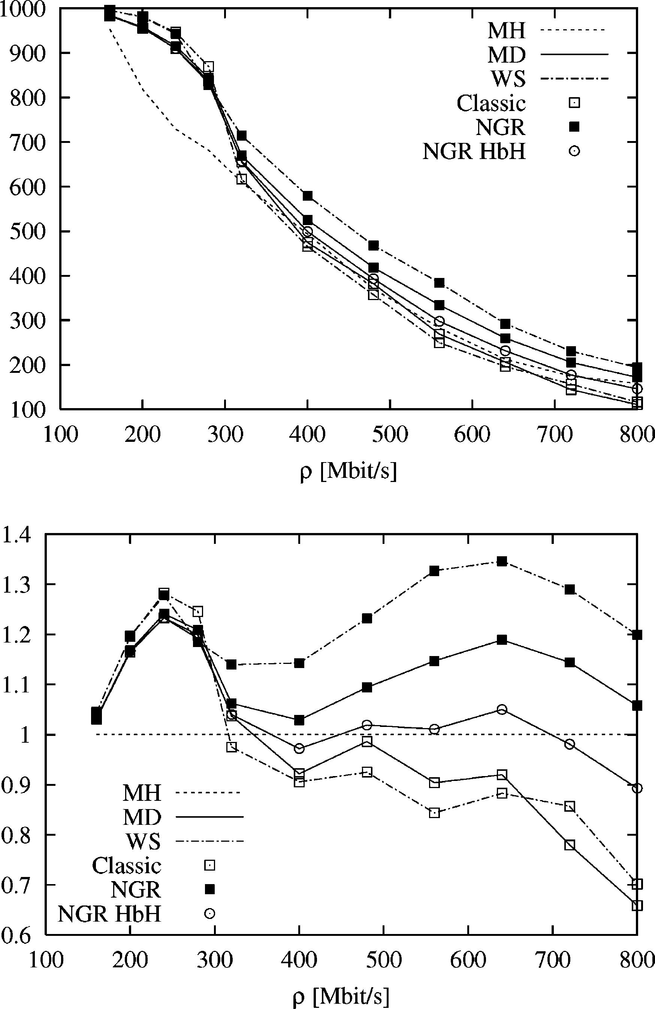
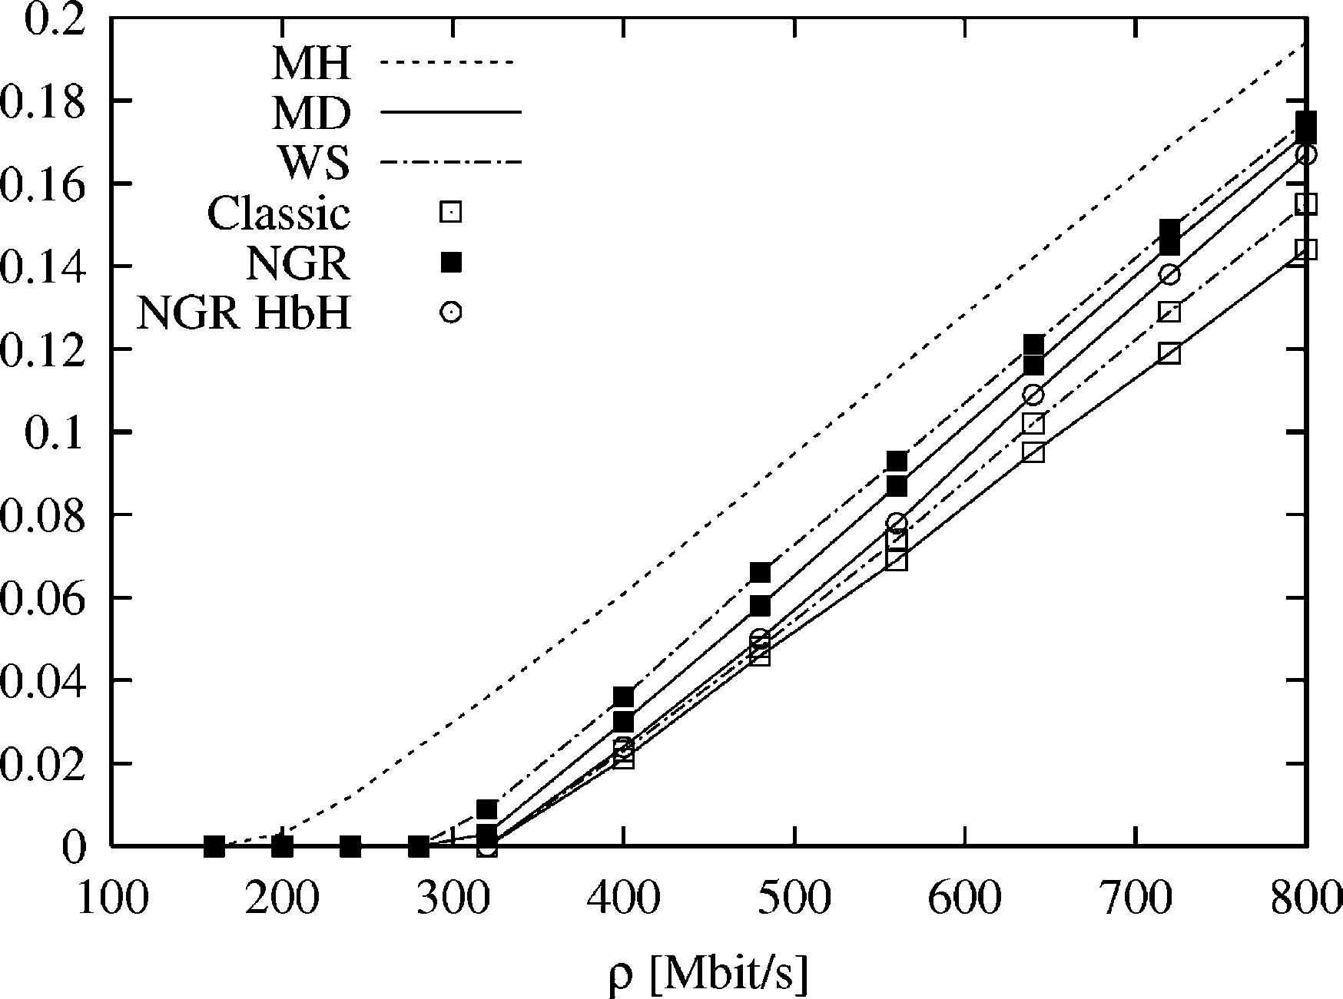

C. Casetti et al. / Computer Networks 41 (2003) 475–487

483

Fig. 4. Average per-connection throughput on network (A)
with uniform and stationary traﬃc pattern; absolute value (kb/
s) (upper plot) and value normalized w.r.t. MH (lower plot).

work load for all routing algorithms, since the
number of competing connections increases, and
elastic connections adapt their sending rate ac-
cording to a max–min fair-share algorithm.
The advantage of QoS routing algorithms over
MH at low loads is clear, but while the classic MD
and WS implementations fall below the MH at
high loads, NGR algorithms always tops MH. The
behavior is all the more evident if we take the
throughput normalized with respect to MH (lower
plot). This can also be seen as the gain of the al-
gorithms as compared to the well-established,
simple MH. It is clear that the MD and WS al-
gorithms are extremely sensitive to the network
load, while the NGR versions perform better than
MH, converging to its performance as q grows

larger. Interestingly, the hop-by-hop implementa-
tion of NGR routing (NGR HbH) feature a per-
formance midway between the consistent version
and the classic algorithms, thus conﬁrming that
locally-optimal decisions are aﬀected by perfor-
mance degradation that limit the beneﬁts of the
NGR approach.
In addition, the NGR-WS algorithm performs
better than the NGR-MD, since the path set it
chooses from only includes minimum-hop ones.
Indeed, the achieved gain is always larger than
15%. The non-monotonic relative behavior of the
algorithms is due to the ‘‘randomness’’ of the to-
pology that is neither regular nor a ‘‘well deﬁned’’
hierarchical topology, which causes diﬀerent por-
tion of the network to become congested depend-
ing on the values of oﬀered load, and on the
speciﬁc QoS routing algorithm implemented.
One might wonder whether connections com-
pleting their information transfer obtain a larger
throughput simply thanks to the larger number of
starved connections shutting down, thus leaving
more resources up for grabs. Figs. 5 and 6 shed
some light on this issue. Fig. 5 reports the proba-
bility that connections close up because they are
starved. NGR algorithms show a starvation prob-
ability that is between MH (the highest) and the
classic MD and WS algorithms. In more detail, the
starvation probability measured is negligible for all
the QoS algorithms for values of the oﬀered traﬃc

Fig. 5. Average starvation probability on network (A); uniform
and stationary traﬃc pattern.

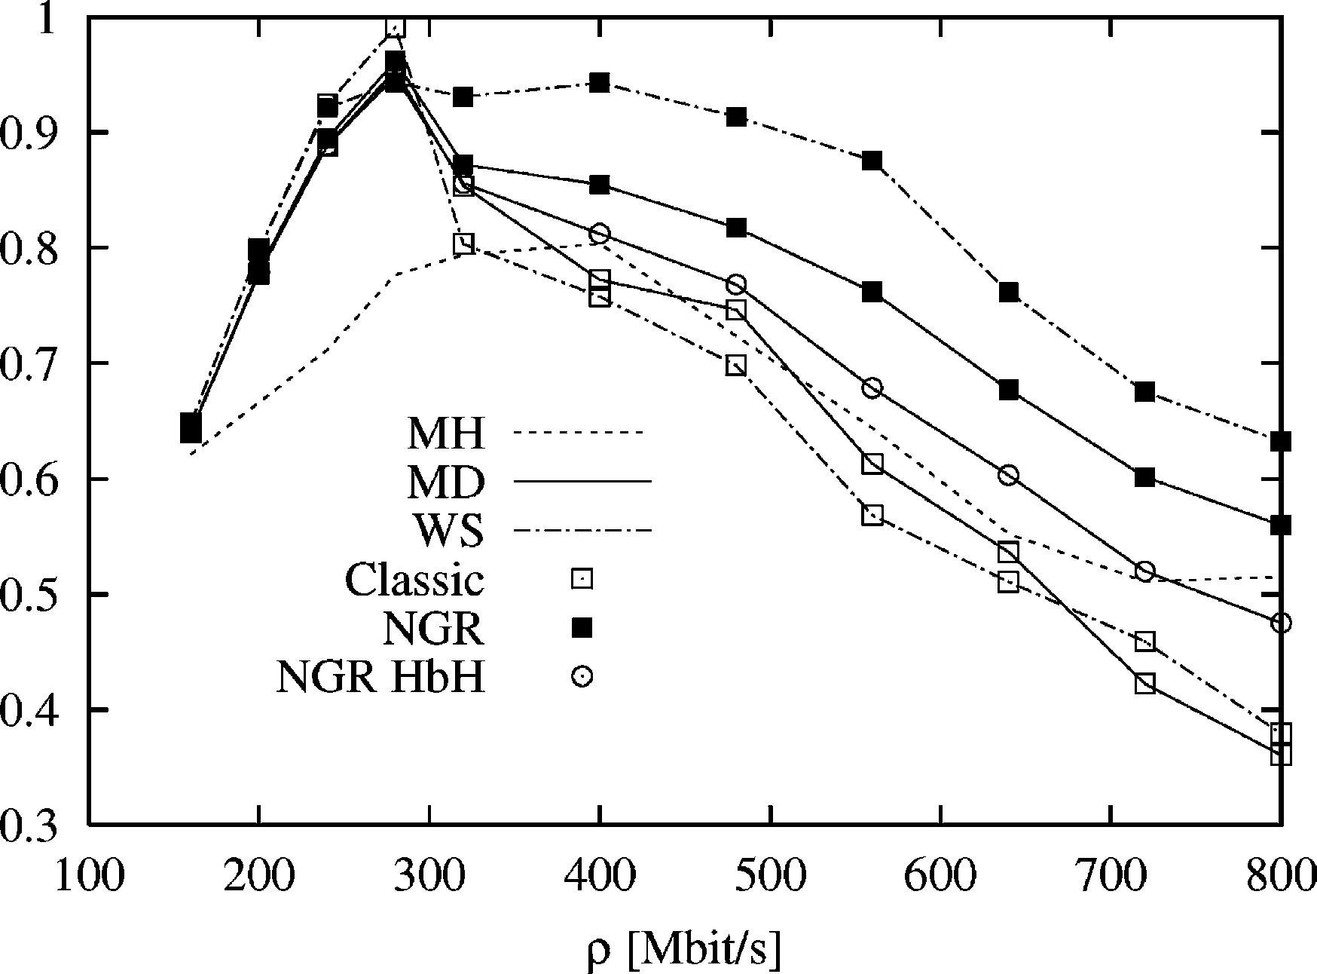
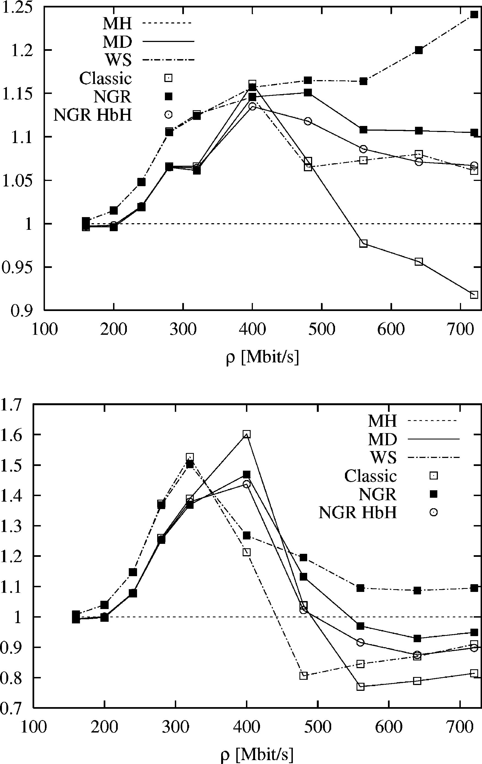

484

C. Casetti et al. / Computer Networks 41 (2003) 475–487

Fig. 6. Total network throughput on network (A); uniform and
stationary traﬃc pattern.

smaller than about 300 Mb/s, while the MH al-
gorithm shows an earlier increase in the starvation
probability, at about 200 Mb/s of oﬀered traﬃc.
Then, a linear increase is shown by all the pro-
posed algorithms.
Fig. 6, ﬁnally, reports the net total utilization of
the network, i.e., the total amount of useful in-
formation carried by the network, normalized with
respect to the total installed bandwidth.⁴
While all the QoS routing algorithms sport a
better utilization of the network capacity at low
values of oﬀered load, the classic MD and WS
algorithms show steep decreases in the through-
put, mitigated by the NGR implementations,
which shows the highest throughput, up to 30%
larger than either MH, MD or WS algorithms.

4.2.2. Network (B)
In the case of the client–server model with
non-stationary traﬃc, it is more interesting to
separately look at clientХs and serverХs behavior,
especially in view of the high level of traﬃc gen-
erated by the servers during their active cycles. Fig.
7 shows the average throughput per connection
normalized to the one obtained by MH, while Fig.
8 reports the absolute values. The upper plot refers

4 The total installed bandwidth is simply deﬁned as the sum
of the capacity of all the links in the network.

Fig. 7. Per-connection average throughput (normalized w.r.t.
MH) of clients (upper plot) and servers (lower plot) on network
(B) with client–server, non-stationary traﬃc pattern.

to clients while the lower plots refer to servers.
Also in this case the NGR version of the algo-
rithms outperforms the classic QoS routing. The
more complex nature of the traﬃc pattern which
keeps changing during time, reduces the gain ob-
served for the client connections to less than 20%.
On the contrary, the performances obtained by
server nodes are greatly improved by any QoS
routing for relatively low load, with the classic
MD showing a clear edge. But as soon as the
network load increases over 500 Mb/s, their per-
formance worsen, while the NGR versions still
exhibit a better utilization of the network capacity.
Figs. 9 and 10 report the probability of star-
vation and the total network throughput (again,

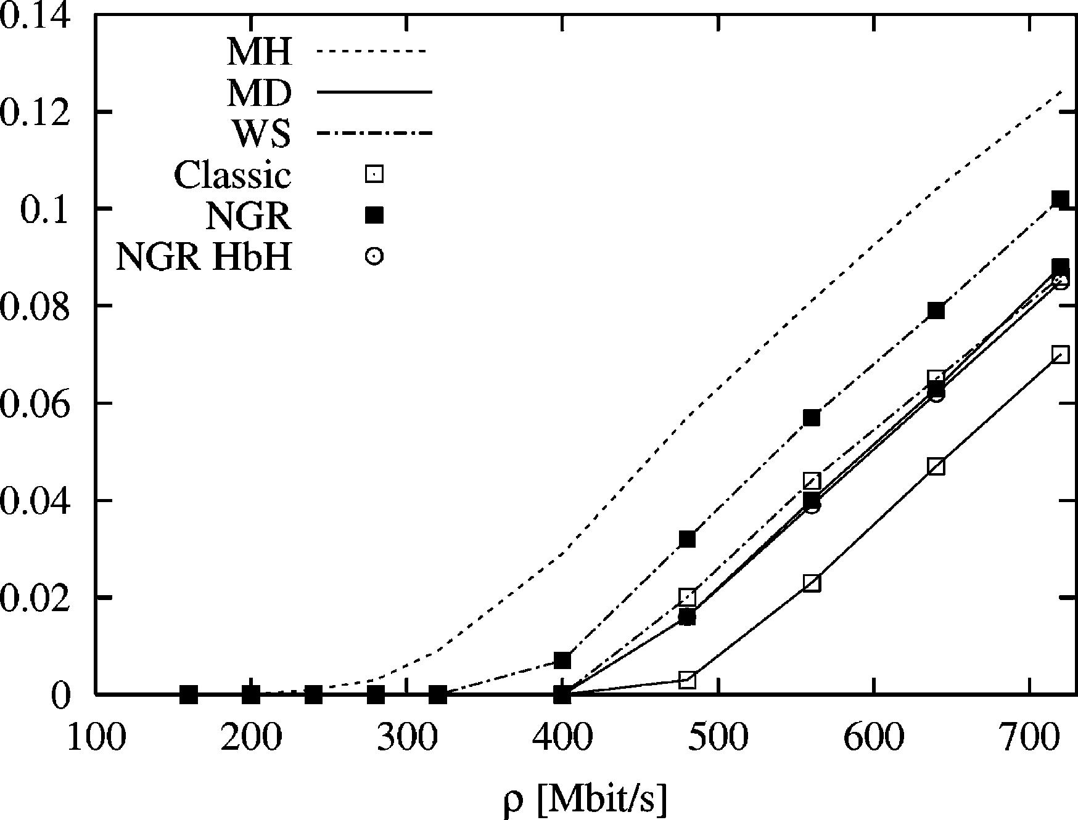
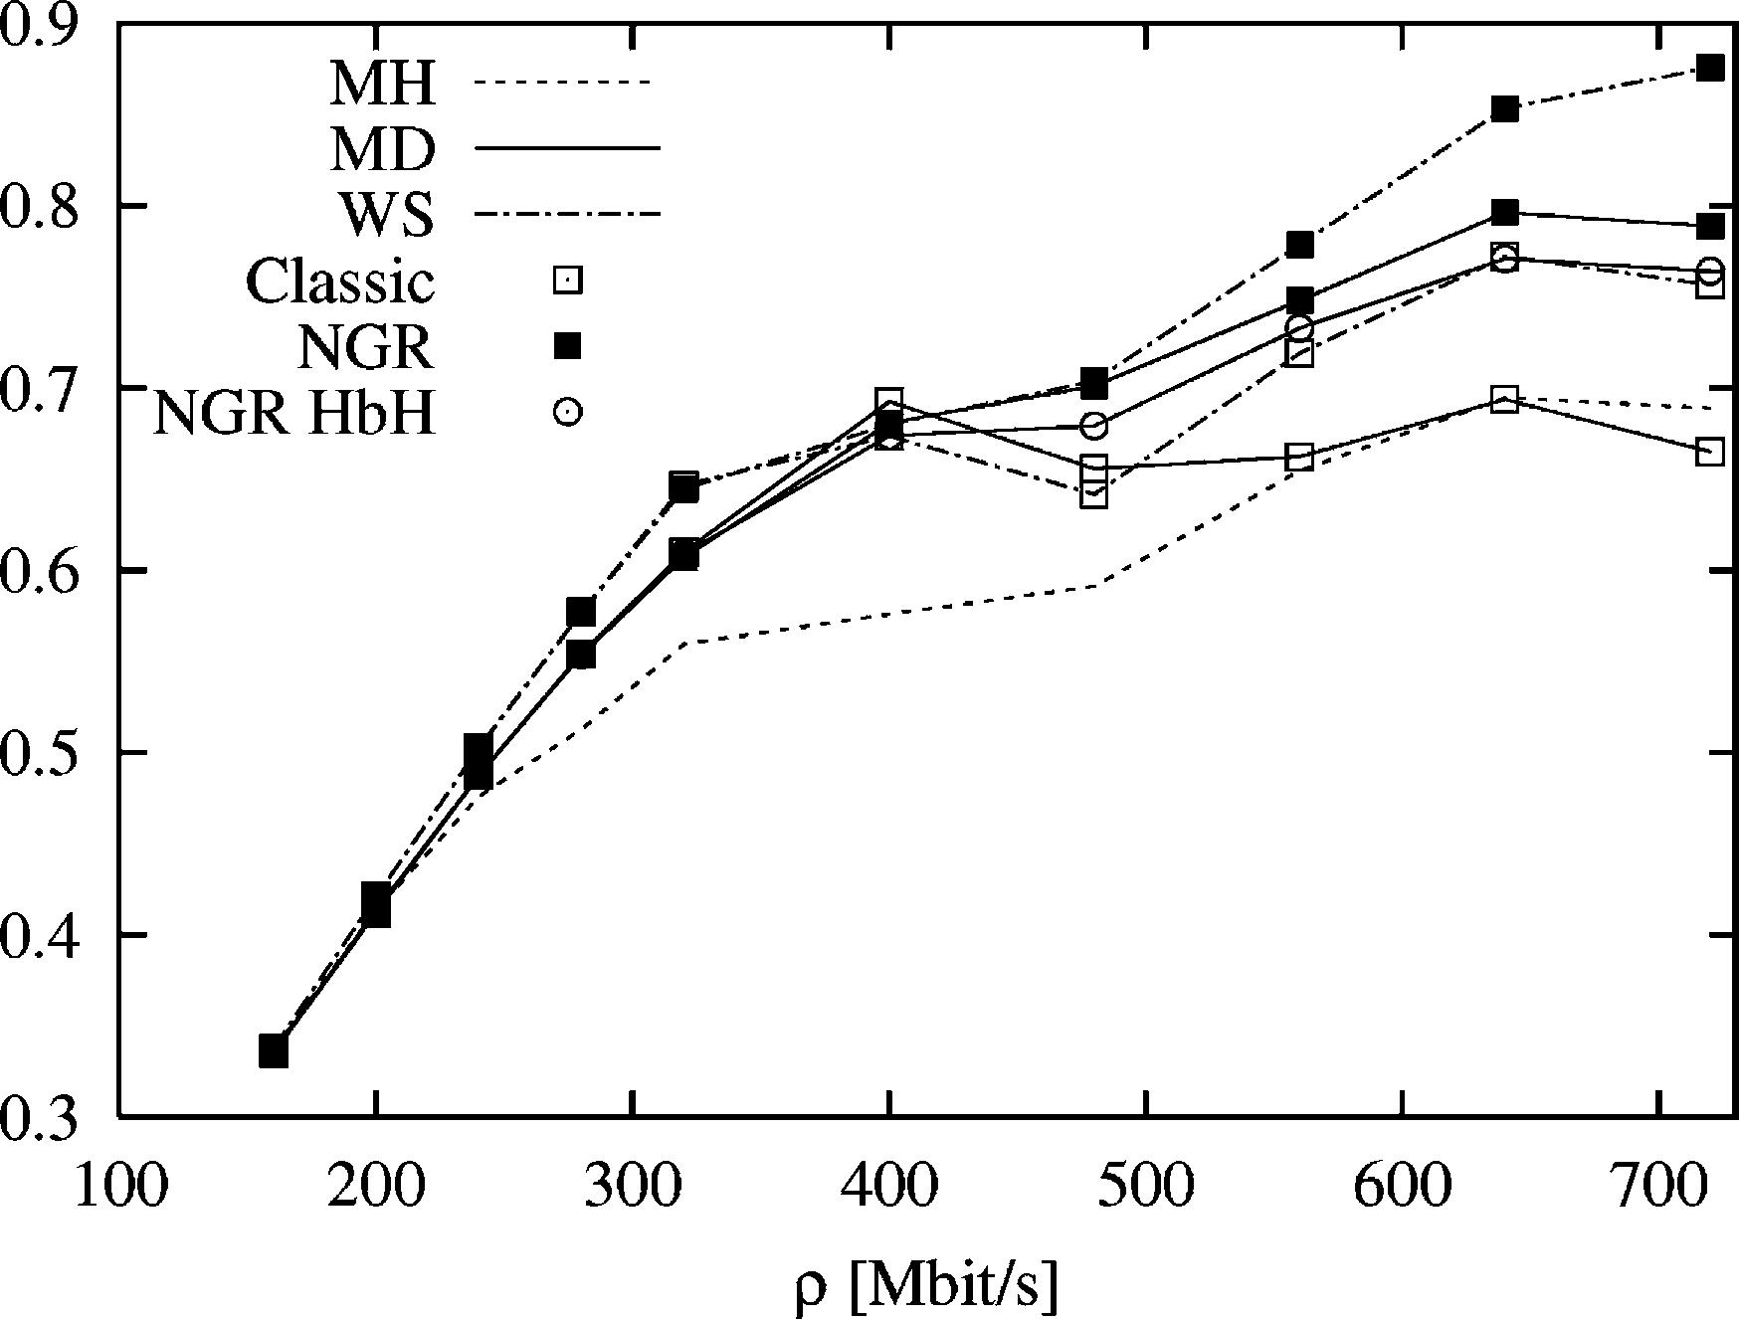
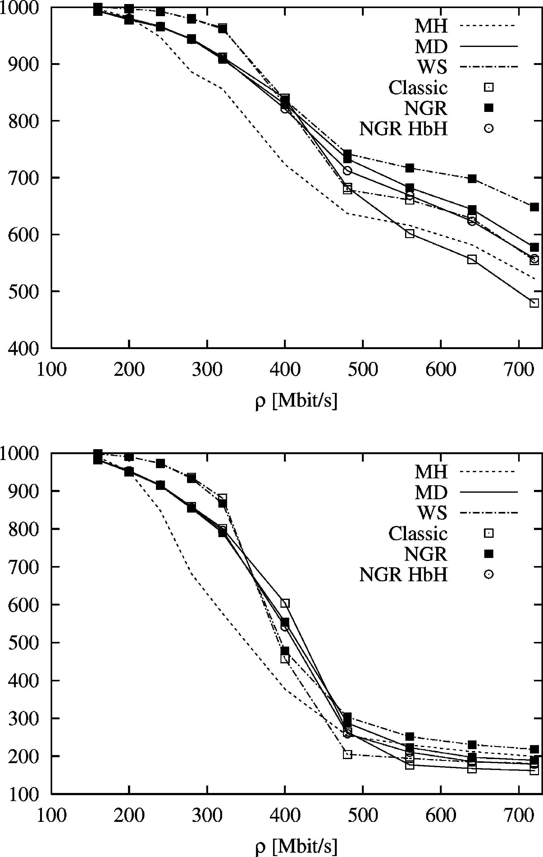

C. Casetti et al. / Computer Networks 41 (2003) 475–487

485

Fig. 8. Per-connection average throughput of clients (upper
plot) and servers (lower plot) on network (B) with client–server,
non-stationary traﬃc pattern.

only the useful portion of it) respectively; in both
cases, results are averaged including both servers
and clients. The starvation probability conﬁrms
results discussed about network (A). It shows that
the use of QoS routing greatly reduces the star-
vation probability, reﬂecting a better distribution
of the traﬃc on the network. Also in this case, the
NGR-MD and NGR-WS algorithms exhibit a
slightly higher starvation probability.
Considering the network throughput reported
in Fig. 10, we can observe that the network ca-
pacity is not completely saturated by the oﬀered
traﬃc, at least during the period of time when the
servers are in the low-traﬃc regime. Given the
complex network topology and traﬃc pattern, it is
very diﬃcult to predict the performance, especially

Fig. 9. Average starvation probability on network (B); client–
server and non-stationary traﬃc pattern.

Fig. 10. Total network throughput on network (B); client–
server and non-stationary traﬃc pattern.

for high values of the oﬀered load. However, also
in this case the best performance is obtained by the
NGR algorithms.

5. Discussion and work evolution

The search for eﬃcient and robust routing al-
gorithms that can replace the traditional MH
routing used in TCP/IP networks has received, and
is still receiving, considerable attention; however, so
far, none of the proposals seems to oﬀer enough
beneﬁts to counter-balance the necessarily increased
complexity. In particular, robustness to changes in



486

C. Casetti et al. / Computer Networks 41 (2003) 475–487

traﬃc pattern and, most of all, to sudden load in-
creases is a major concern, since all QoS-based al-
gorithms seem to perform worse than the simple
MH algorithm as the network load increases.
Since the optimality of MH routing can be
demonstrated under some simplifying assump-
tions, and can be inferred under more realistic
scenarios, a robust and resilient routing algorithm
should converge to the MH routing as the traﬃc
load grows larger and larger.
Pursuing this idea, in this paper we have pro-
posed and discussed a new class of routing algo-
rithms that exhibit this property and that are
shown to outperform both the MH and traditional
QoS-based algorithms in simulation. These rout-
ing algorithms are based on a technique which
reduces the graph describing the network to a
graph containing only uncongested links. The se-
lection of the path is then performed on a set
containing paths evaluated on the reduced graph,
plus the minimum-hop path itself. In their con-
sistent form, these routing algorithms cannot be
implemented by a standard hop-by-hop proce-
dure, but require either the use of MPLS tech-
niques, or a (simple) modiﬁcation of the IP
forwarding. Simulation results, as well as intuition,

[4] D. Cavendish, M. Gerla, Internet QoS routing using the
Bellman–Ford algorithm, in: High Performance Network-
ing (HPN98), IFIP, Vienna, Austria, 1998.
[5] G. Apostolopoulos, R. Gueerin, S. Kamat, S.K. Tripathi,
Quality of service based routing: a performance perspec-
tive, in: ACM SIGCOMMХ98, Vancouver, Canada, Sep-
tember 1998.
[6] G. Apostolopoulos, D. Williams, S. Kamat, R. Guerin, A.
Orda, T. Przygienda, QoS Routing Mechanisms and OSPF
Extensions, RFC 2676, August 1999.
[7] A. Shaikh, J. Rexford, K. Shin, Load-sensitive routing of
long-lived IP ﬂows, in: ACM SIGCOMM Х99, Cambridge,
MA, August 1999, pp. 215–226.
[8] J. Moy, Open Shortest Path First version 2, RFC 2328,
April 1998.
[9] Ross Callon, Use of OSI IS–IS for Routing in TCP/IP and
Dual Environments, RFC 1195, December 1990.
[10] D. Bertsekas, R. Gallager, Data Networks, second ed.,
PrenticeHall, Englewood Cliﬀs, NJ, 1992.
[11] S. Sibal, A. De Simone, Controlling alternate routing in
general-mesh packet ﬂow networks, in: ACM SIGCOMM
Х94, London, UK, August 1994.
[12] J.L. Sobrinho, Algebra and algorithms for QoS path
computation and hop-by-hop routing in the Internet, IEEE
Transactions on Networking 10 (4) (2002) 541–550.
[13] C. Casetti, G. Favalessa, M. Mellia, M. Munafo
adaptive routing algorithm for best-eﬀort traﬃc in inte-
grated-services networks, in: Sixteenth International Tele-
traﬃc Congress (ITC-16), Edinburgh, UK, June 1999.
[14] E. Rosen, A. Viswanathan, R. Callon, Multi-Protocol
Label Switching Architecture, RFC 3031, January 2001.

have shown that a locally-optimal hop-by-hop
[15] C. Casetti, R. Lo Cigno, M. Mellia, M. Munafo
o

implementation of these algorithm is liable to
performance degradation, while still retaining
Routing algorithms evaluation for elastic traﬃc, in: IEEE
Workshop on High Performance Switching and Routing
(HPSR 2001), Dallas, Texas, May 29–31, 2001.

some advantages over classical algorithms.
[16] C. Casetti, R. Lo Cigno, M. Mellia, M. Munafo
o

Further research in this area should address the
possibility of ﬁnding a similar class of routing al-
gorithms that are, however, implementable in a
hop-by-hop fashion without requiring any modi-
ﬁcation to the standard IP forwarding.

References

[1] Z. Wang, J. Crowcroft, QoS routing for supporting multi-
media applications, IEEE JSAC 14 (7) (1996) 1228–1234.
[2] Q. Ma, P. Steenkiste, H. Zhang, Routing high-bandwidth
traﬃc in max–min fair share networks, in: ACM SIG-
COMMХ96, Stanford, CA, August 1996, pp. 206–217.
[3] Q. Ma, P. Steenkiste, Routing traﬃc with quality-of-service
guarantees in integrated services networks, in: Eighth
IEEE/ACM International Workshop on Network and
Operating Systems Support for Digital Audio and Video
(NOSSDAVХ98), England, July 1998.
A realistic model to evaluate routing algorithms in the
internet, in: IEEE Globecom 2001, San Antonio, Texas,
November 25–29, 2001.
[17] ANCLES––A Network Call-Level Simulator. Available
from: <http://www.telematics.polito.it/ancles>.
[18] GT-ITM Georgia Teach-Internetwork Topology Models.
Available from: <http://www.cc.gatech.edu/projects/gtitm>.

Claudio Casetti graduated from the
Politecnico di Torino with a MasterХs
degree in Electronic Engineering in
1992 and a Ph.D. in Electronic and
Telecommunication Engineering in
1997. He was a visiting scholar at the
University of Massachusetts at Am-
herst in 1996 and at UCLA in 2000. He
is currently holding an Assistant Pro-
fessor position at the Dipartimento di
Elettronica e Telecomunicazioni of
Politecnico di Torino. He has coau-
thored about 40 journal and conference
papers in the area of communication
networks. His interests are in the ﬁeld of performance evaluation
of TCP/IP networks and multimedia communications.






C. Casetti et al. / Computer Networks 41 (2003) 475–487

487

Renato Lo Cigno was born in Ivrea,
Italy in 1963. He received a Dr. Ing.
degree in Electronic Engineering from
Politecnico di Torino in 1988. Since
then he has been with the telecommu-
nication research group of the Elec-
tronics Department of Politecnico di
Torino, ﬁrst as Research Engineer and
then as Assistant Professor. Starting
November 2002 he holds a position as
Associate Professor at the University
of Trento, Italy.
From June 1998 to February 1999,
he was at the CS Department at
UCLA as Visiting Scholar under grant CNR 203.15.8. He is
coauthor of about 80 journal and conference papers in the area
of communication networks and systems. He was in the pro-
gram committee of IEEE Globecom and IEEE ICNP.
His current research interests are in performance evaluation of
wired and wireless networks, modeling and simulation techniques,
QoS management including routing and congestion control.

Marco Mellia was born in Torino, Italy,
in 1971. He received his degree in Elec-
tronic Engineering in 1997, and a Ph.D.
in Telecommunications Engineering in
2001, both from Politecnico di Torino.
From March to October 1999 he was
with the CS department at Carnegie
Mellon University as visiting scholar.
Since April 2001, he is with Electronics
Department of Politecnico di Torino as
Assistant Professor. His research inter-
ests are in the ﬁelds of: All-Optical
Networks, Traﬃc measurement and
modeling, QoS Routing algorithms.

Maurizio Munafo is Assistant Profes-
sor in the Electronics Department of
Politecnico di Torino. He holds a Dr.
Ing. degree in Electronic Engineering
since 1991 and a Ph.D. in Telecom-
munications Engineering since 1994,
both from Politecnico di Torino.Since
November 1991 he has been with the
Electronics Department of Politecnico
di Torino, where he has been involved
in the development of an ATM net-
works simulator.
He is coauthor of about 30 journal
and conference papers in the area of
communication networks and systems. His current research
interests are in simulation and performance analysis of com-
munication systems and QoS routing algorithms.

Zolta o was born in Budapest,
Hungary, in 1975. He received his
M.Sc. degree in Informatics in 1999
from the Budapest University of
Technology and Economics. Currently
he is doing his Ph.D. studies super-
vised by La o Jereb at the same
university. In 1999 and 2001 he was
with the Electronics department at
Politecnico di Torino, Italy, perform-
ing research activities as visiting scho-
lar. His research interests are in the
ﬁelds of All-Optical Networks, Net-
work Performance studies and QoS
Routing algorithms.

